Problem Statement

HashedIn by Deloitte is interested in developing an online shopping application named HashKart.

HashKart application should be one stop destination for all kind of shopping needs for the customers. The application should enable the users to view all the products items in the cart, to add the required items to the cart, to make the payments successfully and to apply the discount coupons

Your task is to design a system which should be easily scalable, robust, independently deployable, agile, and modern.

High Level Architecture

Considering that your goal to design a scalable, independently deployable application, use microservice architecture pattern to design the application . Shown below is a diagram depicting how the data flow should be.

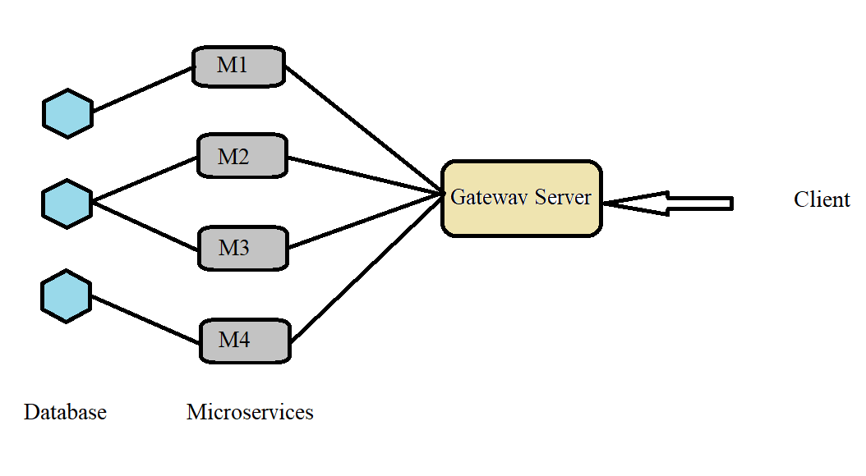

Expectations

1. Users should be able to Signup/login to the application with the credentials.
2. Customers should have access to View all the products and items that are available under different categories and types for the purchase with available quantity.
3. Users should be able to Sort and filter the items based on price, ratings, etc.,
4. They can add the items to the cart and proceed to checkout and make the payment successfully.
5. If the Item is purchased / If the payment fails, the available quantity of the products and items must be updated accordingly in the database
6. All the Payment information must be stored in a database table.
7. Apply the discount coupons/promocode while checking out.
8. Default discounts should be applied if more quantity is purchased for the same items. The discount percentage should not be hard coded in the code, it should be dynamically modifiable from cloud config.

Milestones:

Milestone 1: Designing the Database and Microservices

Milestone 2: Gateway and Naming Server Implementation

Milestone 3: User Authentication and Authorization

Milestone 4: Unit Testing (80% Coverage)

Milestone 5: Dockerize the application

Milestone 6: Deployment into cloud (GCP using Kubernetes)

Note

* Design yourself the required database tables which would be needed to design the HashKart application.
* Use Microservice architecture to implement the necessary services. (It will be considered for evaluation)
* Fault tolerance must be implemented.
* User Authentication also need to be implemented.
* Your **Unit and Integration Test cases** also will be given high priority for evaluation.
* **Use of appropriate Java 8 functionalities** will be considered while evaluation.
* Handle the exceptions properly and in an efficient way, also use logging wherever necessary.
* Follow Git best practices.
* Take special care on coding standards and naming conventions.